AWARENESS CAMPAIGN ON PLASTIC FREE CITY 2019

In pursuance of the letter no. F.20016/1/2018-DTE(HTE), dt. 15th July, 2019 from Directorate of Higher & Technical Education, the Aizawl Municipal Corporation and Eco-Club Govt. Zirtiri Residential Science College jointly organised “Awareness Campaign on Plastic Free City” on 9th August, 2019 at the College Auditorium.
The function commenced at 12:30 pm and was chaired by Mr Laltlanzova Khiangte, Councillor, Ward No. IV of Aizawl Municipal Corporation. The chairman briefly introduced various steps taken recently to ban use of plastics in Aizawl City. After that Mr Lalringliana, Deputy Mayor delivered a speech on the hazards of single-use plastics and how this has become a major issue in environmental pollution. He then proceeded with the future plan of the Corporation to dispose all kinds of non-biodegradable wastes. It was followed by question and answer session in which students and teachers participated actively.
The function came to an end with a vote of thanks from Mrs Sailopuii, Chairman of the Eco-Club, GZRSC. The event was attended by over 210 students along with several teachers of this college.

Report prepared by
C. Lalngaihawma
Secretary
Eco-Club GZRSC

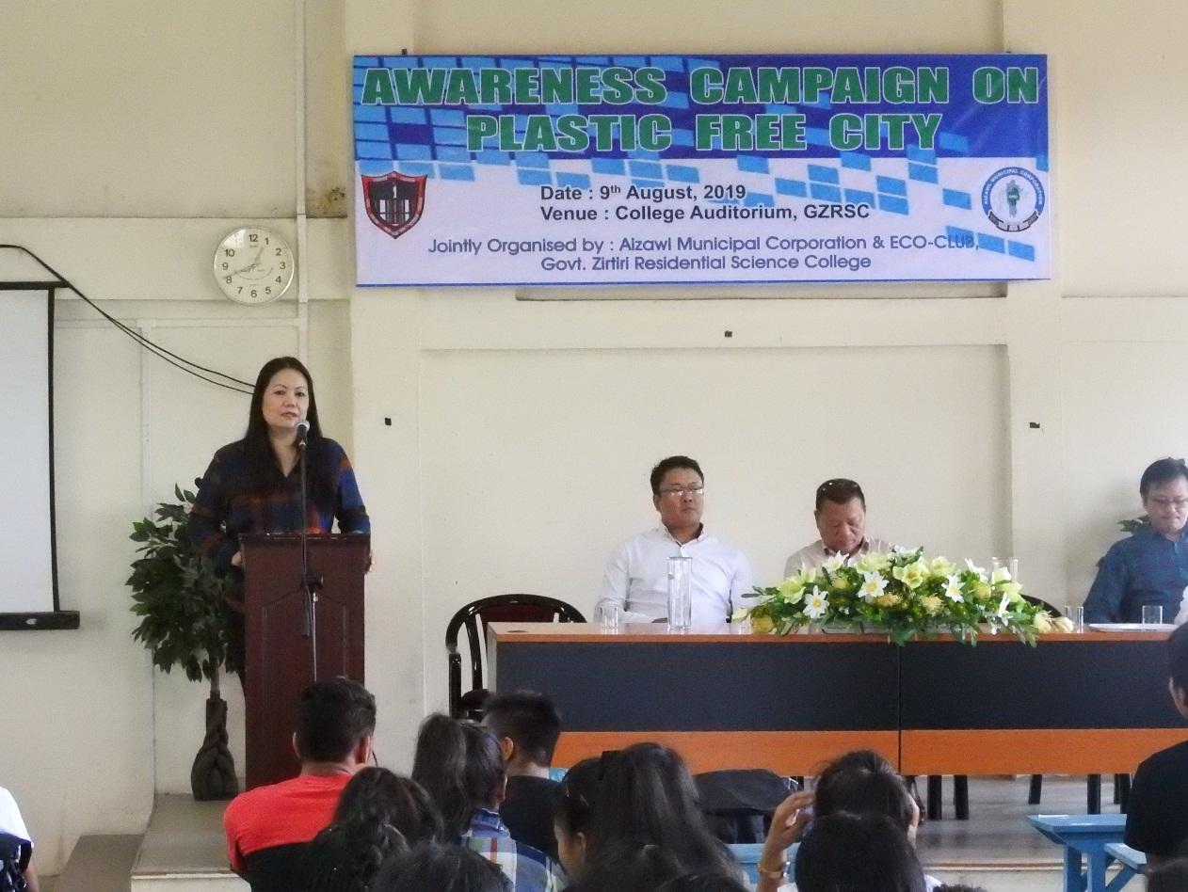
Pic 1: Mrs Sailopuii, Chairman of Eco-Club giving a welcome speech

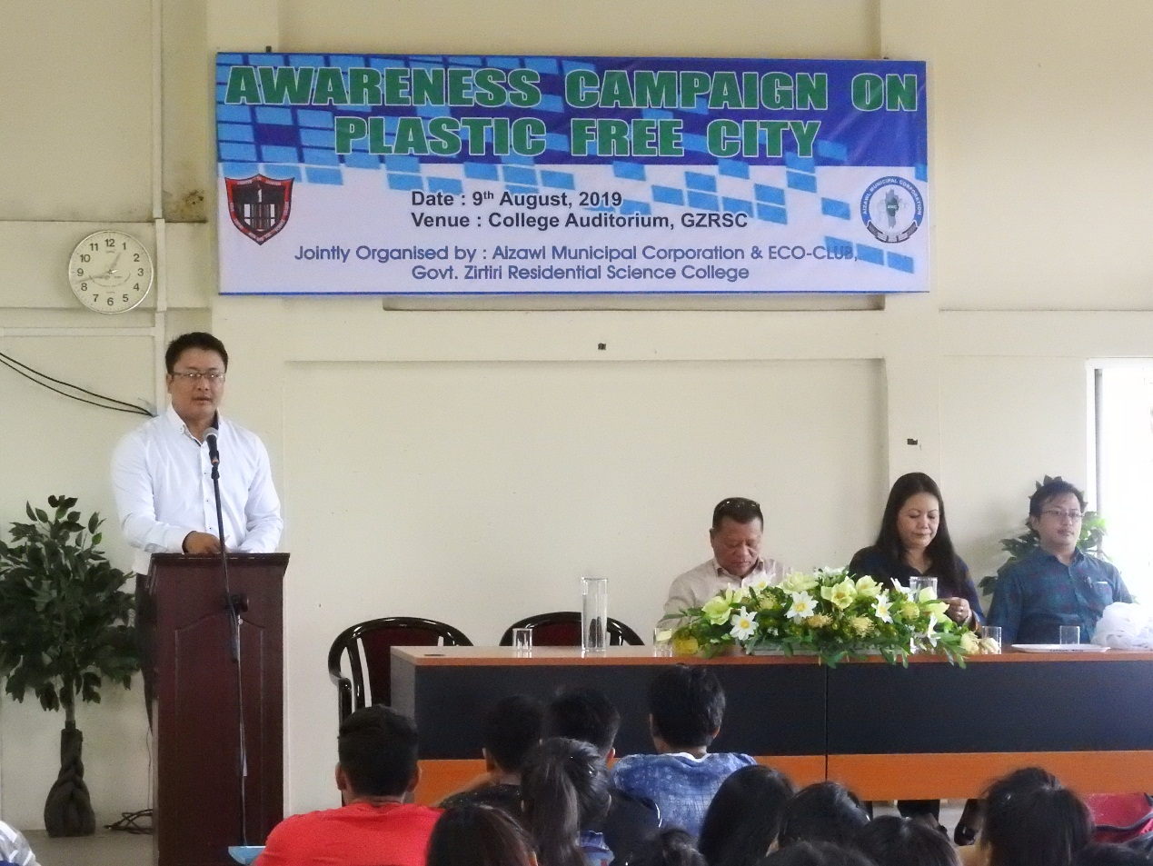
Pic 2: Mr Laltlanzova Khiangte, chairman of the programme
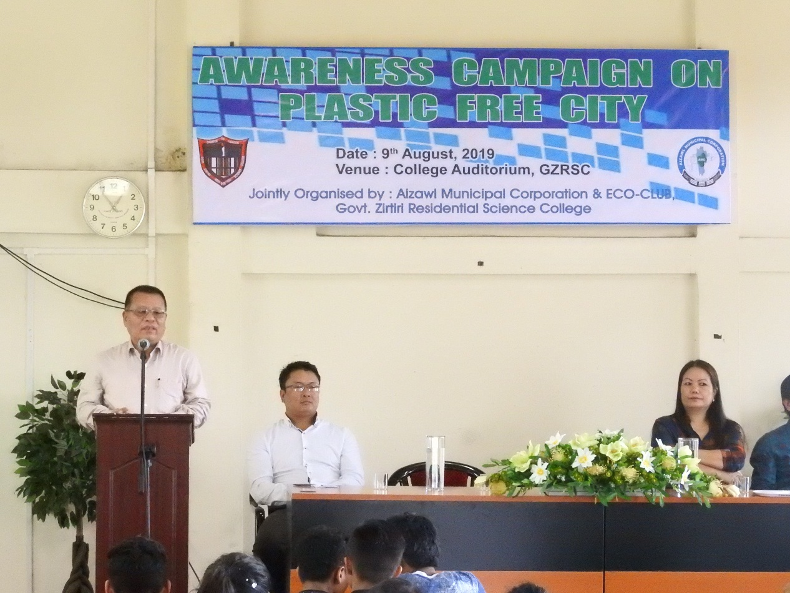
Pic 3: Mr Lalringliana, Deputy Mayor delivering a speech

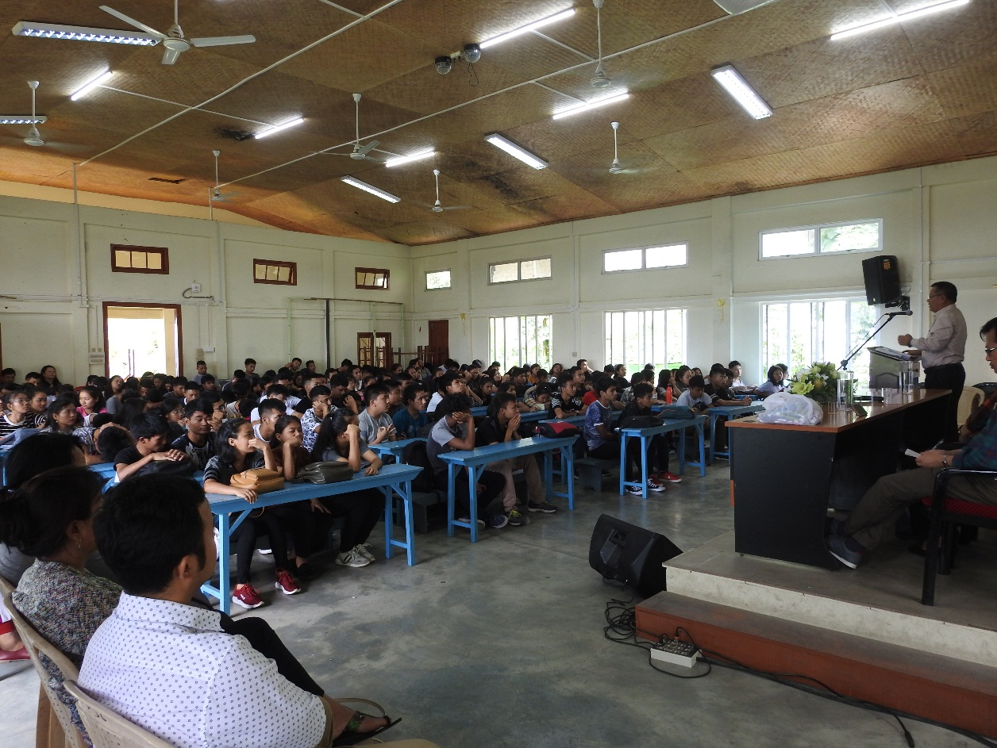
Pic 4: Students of GZRSC
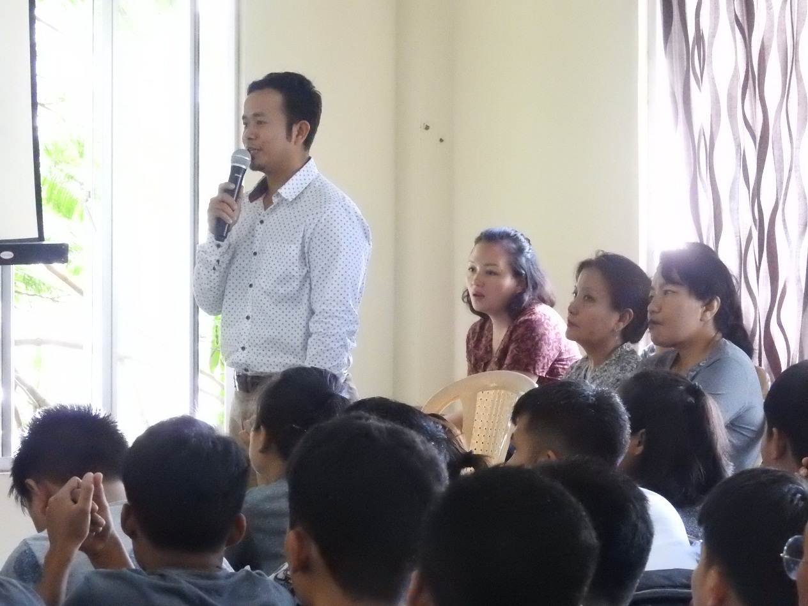
Pic 5: Question and answer session

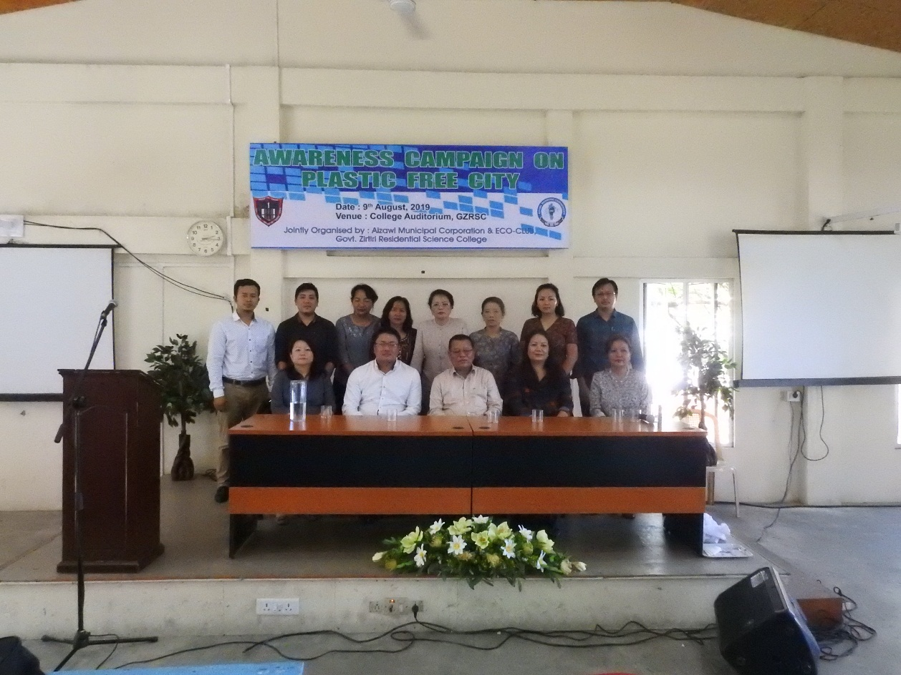
Pic 6: GZRSC faculties with AMC personnel

