SIDBI ADVERTISEMENT POSTER

With reference to the letter no. L202169054/ASW-A24-S00027, dated 2.8.2019, the Innovation Club GZRSC sent a requirement of 5 posters to be displayed in our college building. In response to this, the Assistant Manager, Small Industries Development Bank of India (SIDBI) visited our college to display some posters in the building on 22nd August, 2019. These posters contain informative articles, comic strips etc. on start-ups, government schemes, starting enterprises etc. to provide useful information to the students. The official was assisted by the Chairman and Secretary of the Club as well as some volunteer students.

Report prepared by
C. Lalngaihawma
Secretary
Innovation Club

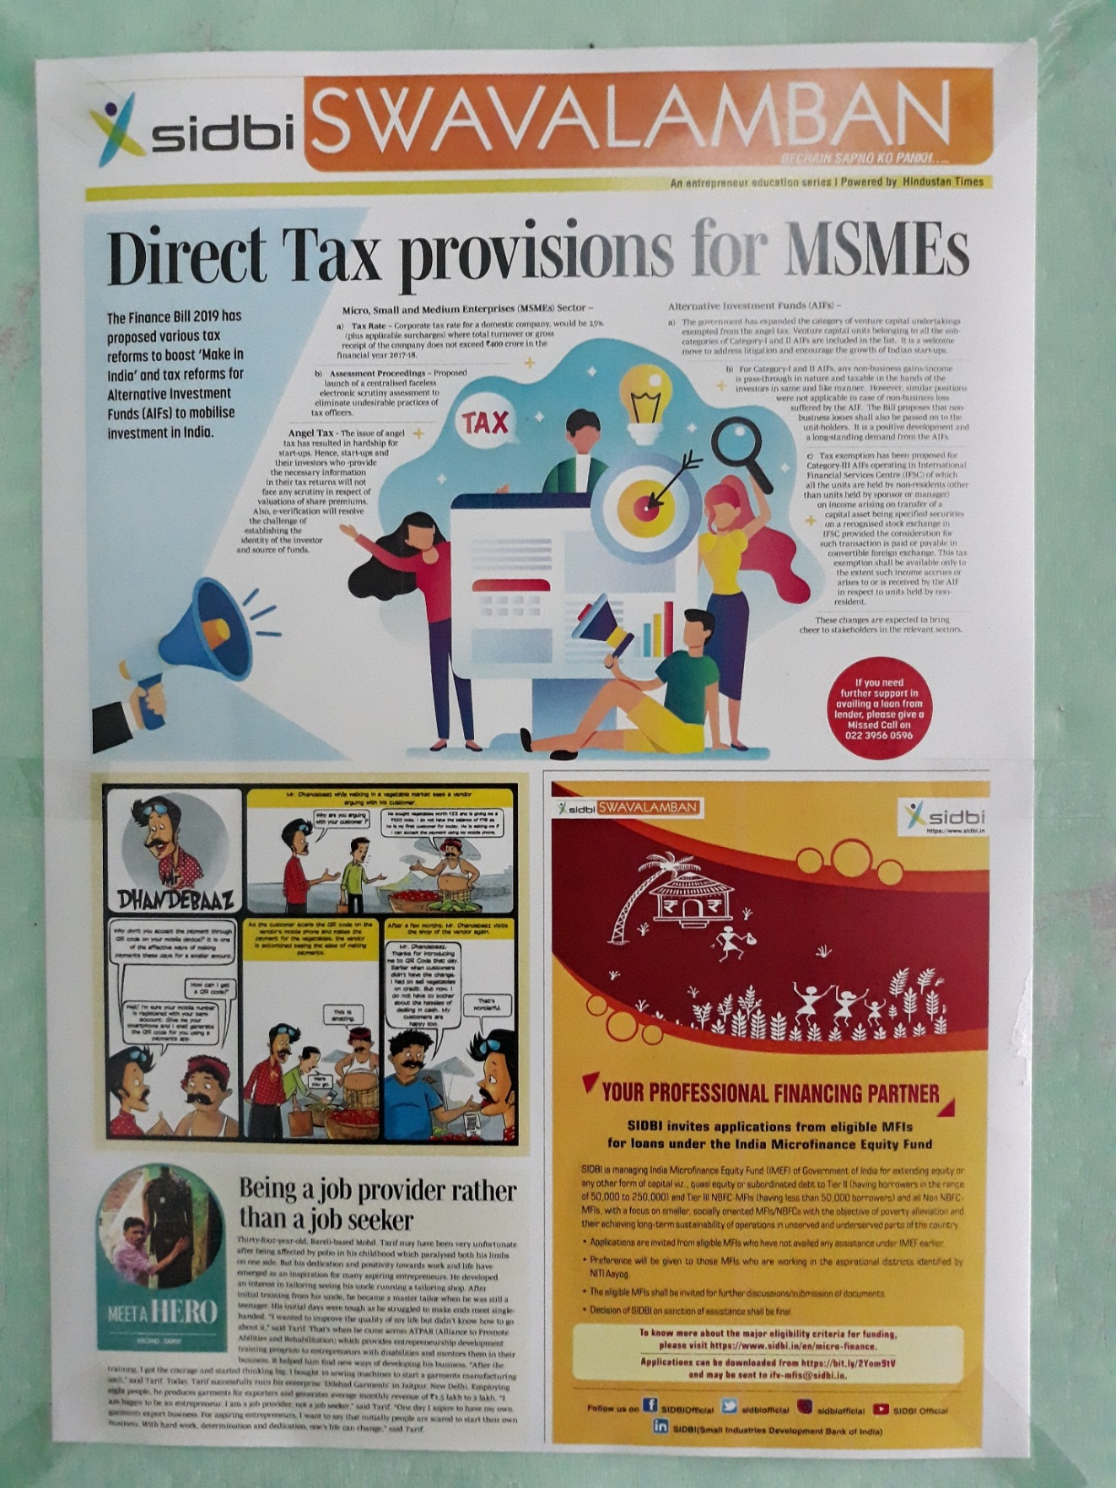
Pic 1
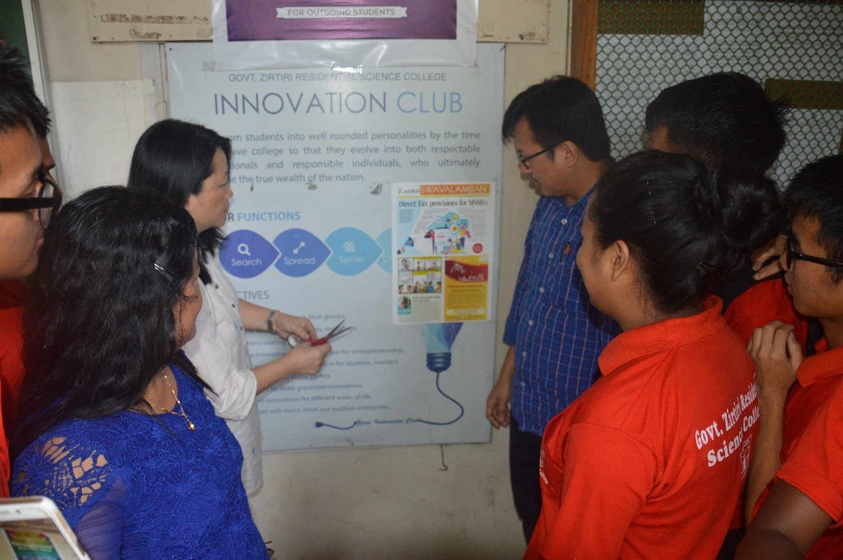
Pic 2

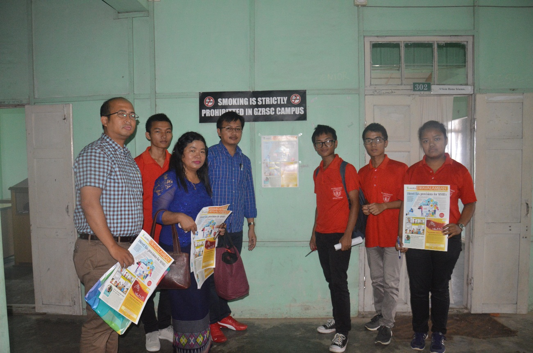
Pic 3
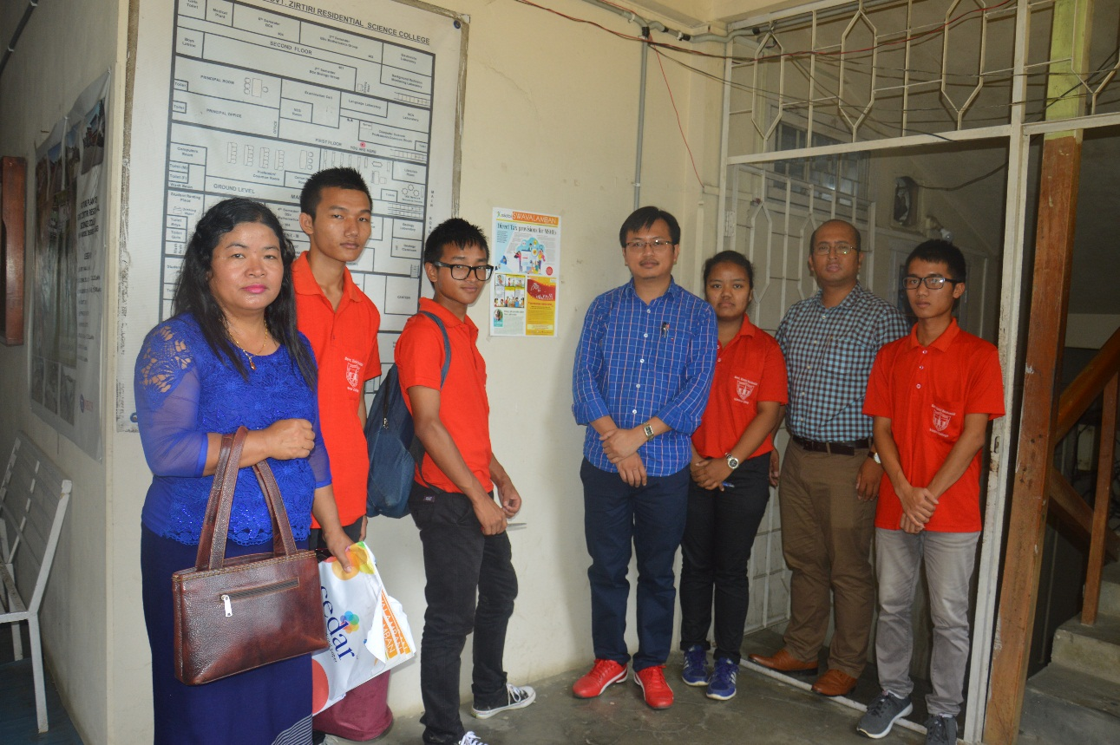
Pic 4

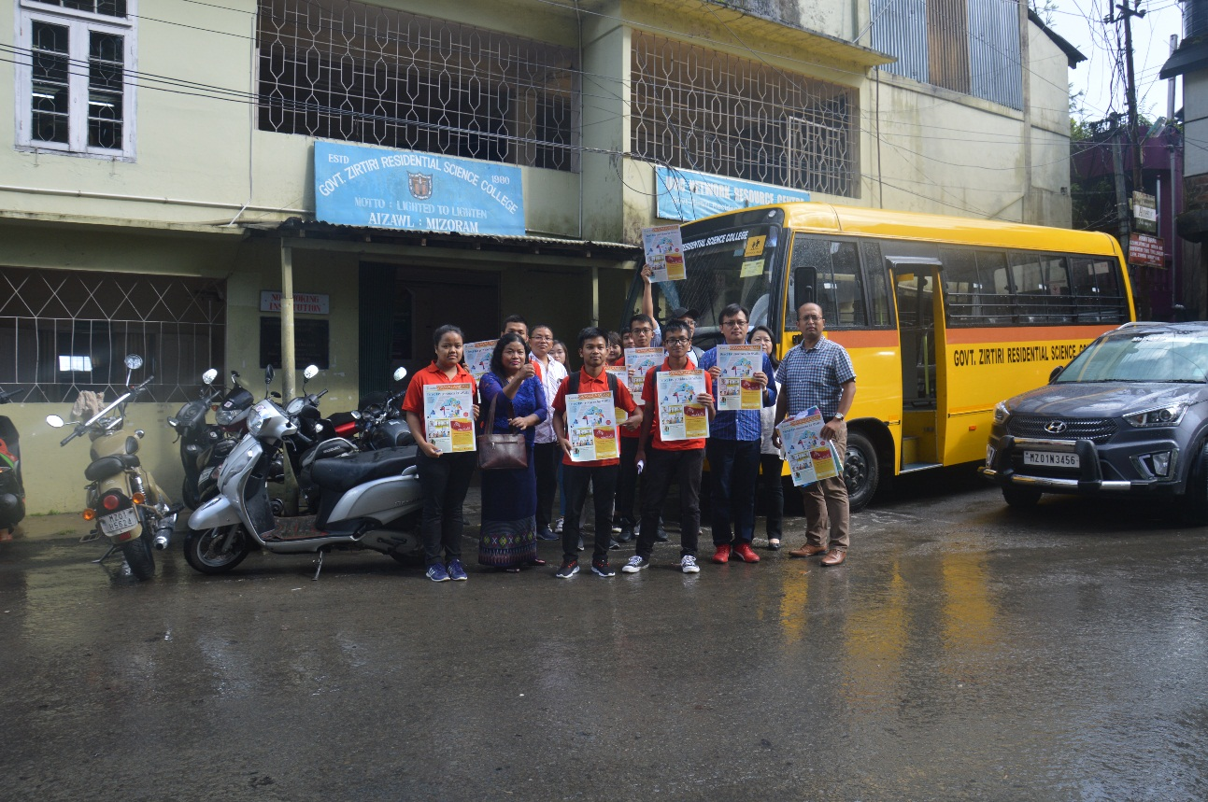
Pic 5

