OBSERVANCE OF WORLD OZONE DAY 2019

In pursuance of the letter no. H.88088/Poltn./91(1)/18-MPCB/25-26 (dt. 9th Sept., 2019) from the Mizoram State Pollution Control Board, the Eco-Club, Govt. Zirtiri Residential Science College, Aizawl observed World Ozone Day 2019 on 16th September at the College Auditorium. The programme was jointly organised by Eco-Club, GZRSC and Mizoram ENVIS Hub, Mizoram State Pollution Control Board.
The function commenced at 2:30 p.m. with a welcome speech from the chairman of the programme, Mr C. Lalngaihawma. After that Mr Lalrinmawia, Associate Professor delivered a lecture on ozone layer depletion and the current measures taken for its recovery. Dodie Zoliansanga of V semester rendered a beautiful song and wowed the crowd with his euphonious voice.
A debate competition was held on this year’s theme “32 Years and Healing” with “Ozone Layer Hi A Dam Tawh Viau A Ni” as the motion, in which 6 students participated. Dr. C. Zoramthara presided over the debate as a speaker, and Mrs Lalthanpuii Ralte, Mr C. Lalremruatfela and Dr Lalzahawmi Chenkual took part as judges. In this competition, C. Lalramtharnghaki, Cindy Lalduhawmi and Lalremsanga won 1st, 2nd and 3rd positions respectively. Prizes and certificates were given away to all the participants.
Mrs C. Malsawmzuali, Information Officer, Mizoram ENVIS Hub delivered a speech on environmental awareness related to ozone and how Mizoram ENVIS Hub has been working to propagate awareness in this regard.
To wind up the function, Mr C. Lalngaihawma delivered a speech and thanked all those involved in making this event a successful one. There was an official photo session followed by a light refreshment.
The function was attended by over 200 people comprising of students and teachers of Govt. Zirtiri Residential Science College and officials from Mizoram State Pollution Control Board.

Report prepared by
C. Lalngaihawma
Secretary
Eco-Club, GZRSC

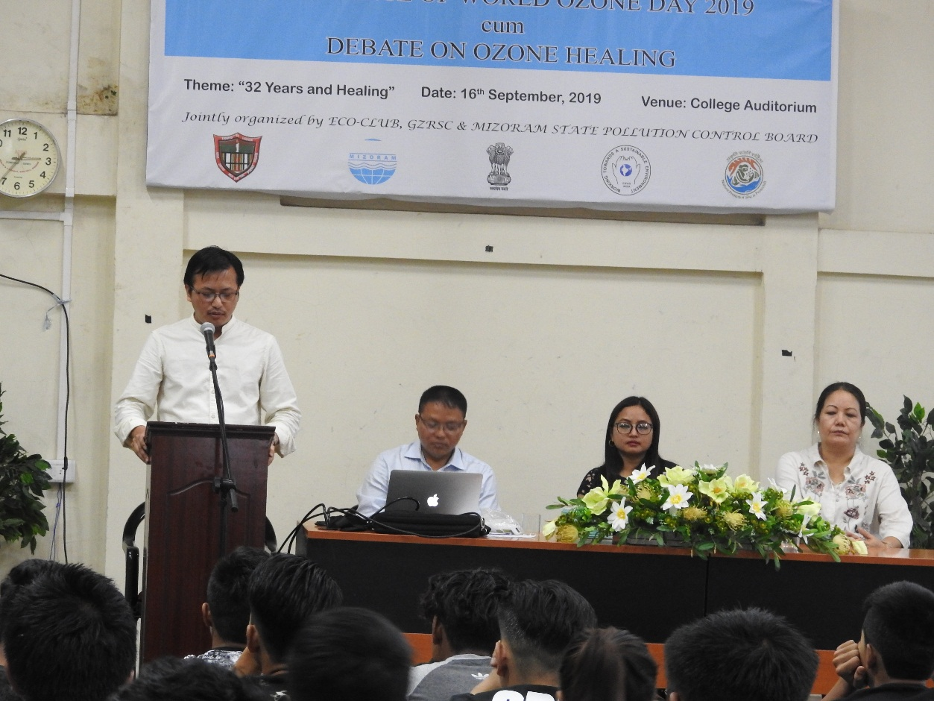
Pic 1: Mr C. Lalngaihawma, chairman of the programme delivering a welcome speech

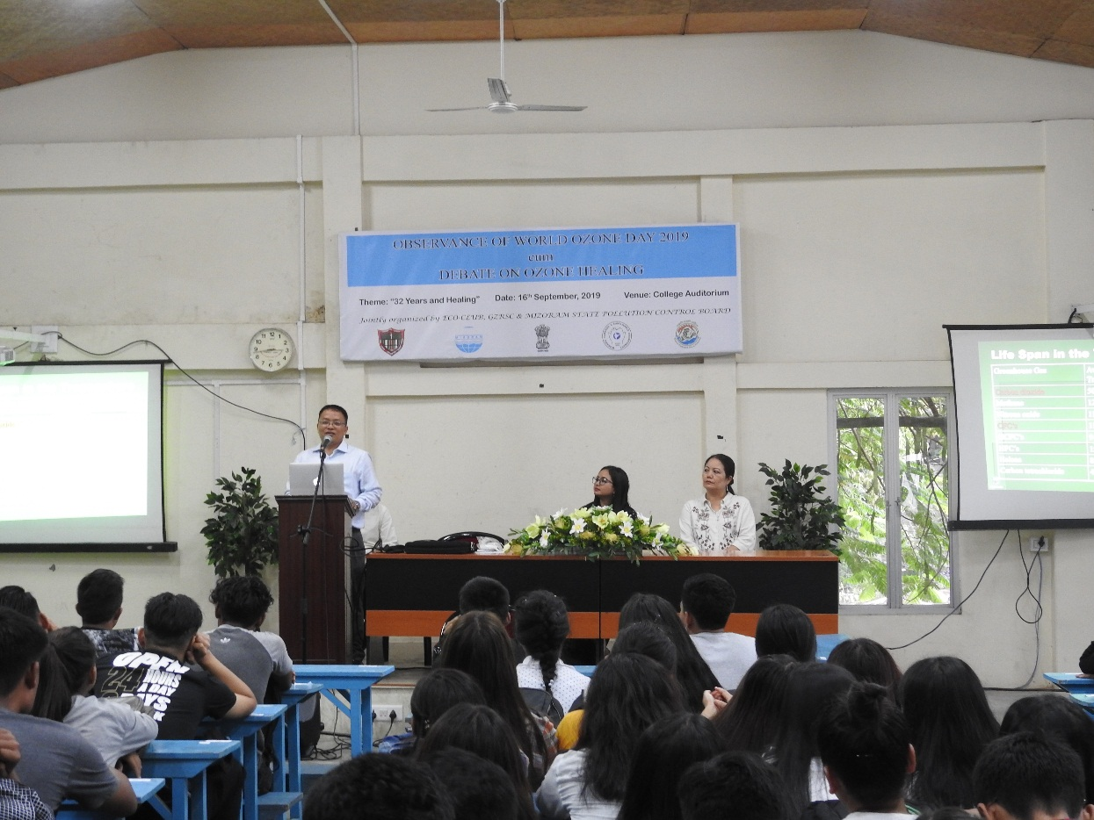
Pic 2: Mr Lalrinmawia, Associate Professor speaking on ozone layer depletion
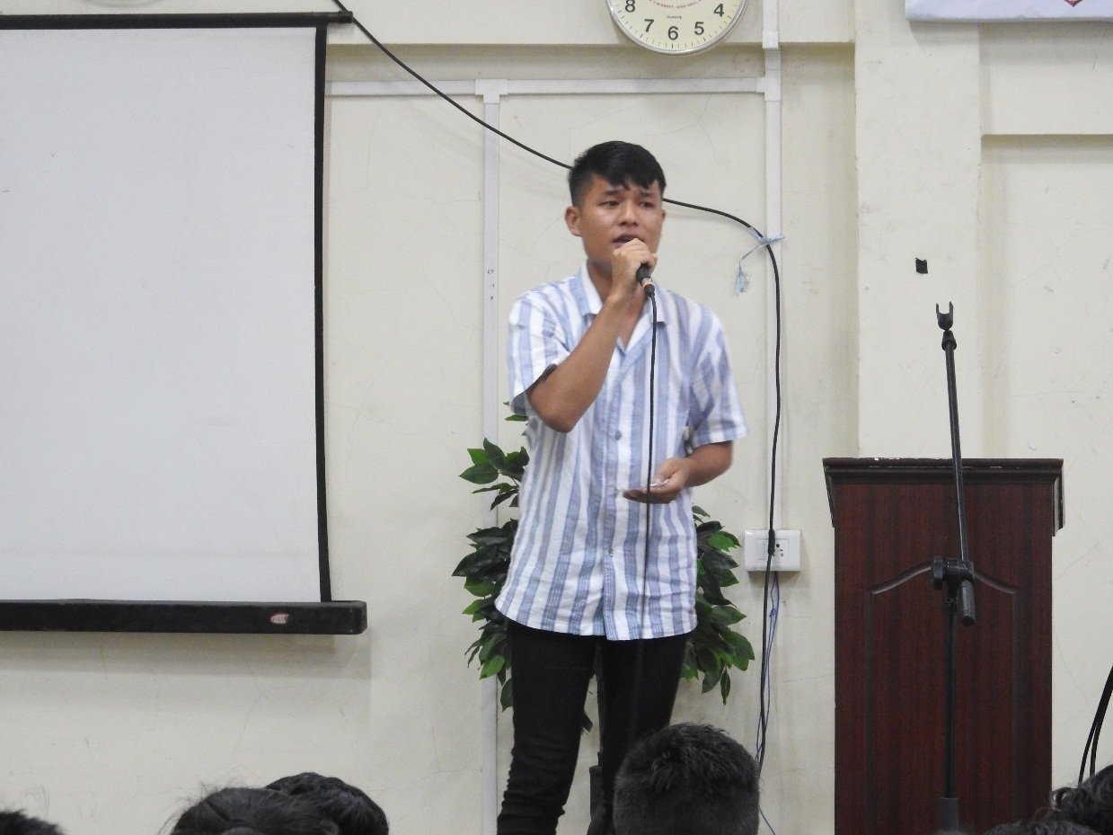
Pic 3: Dodie Zoliansanga rendering a song

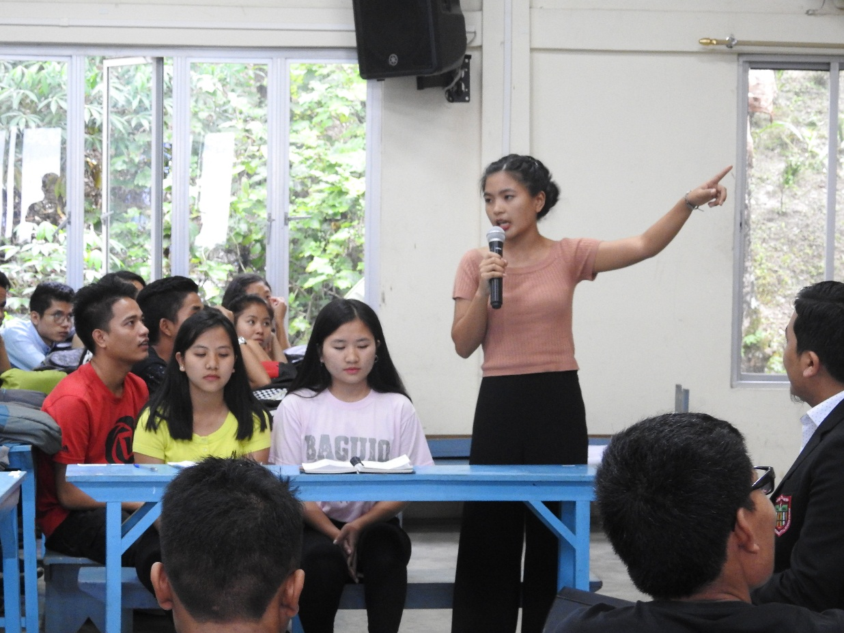
Pic 4: C. Lalramtharnghaki, leader of the movers
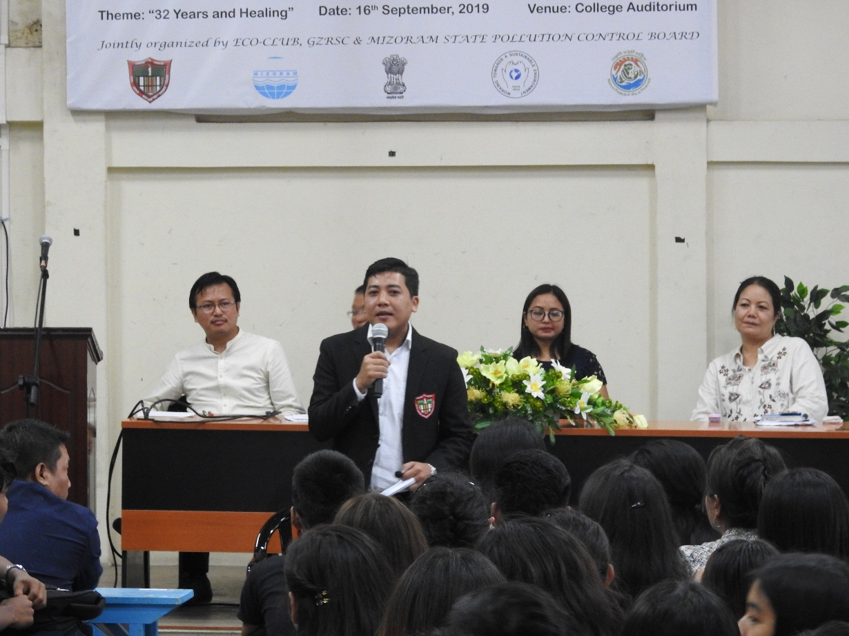
Pic 5: Dr C. Zoramthara giving an instruction as a speaker

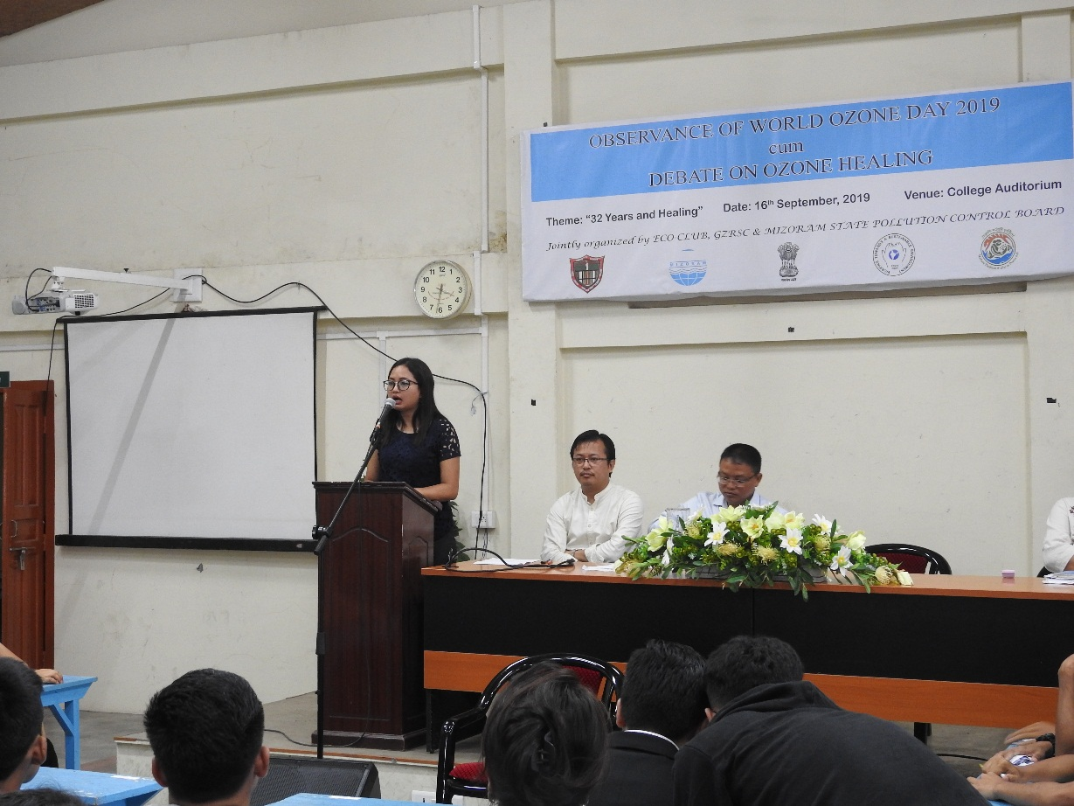
Pic 6: Mrs C. Malsawmzuali, Information Officer speaking on environmental awareness
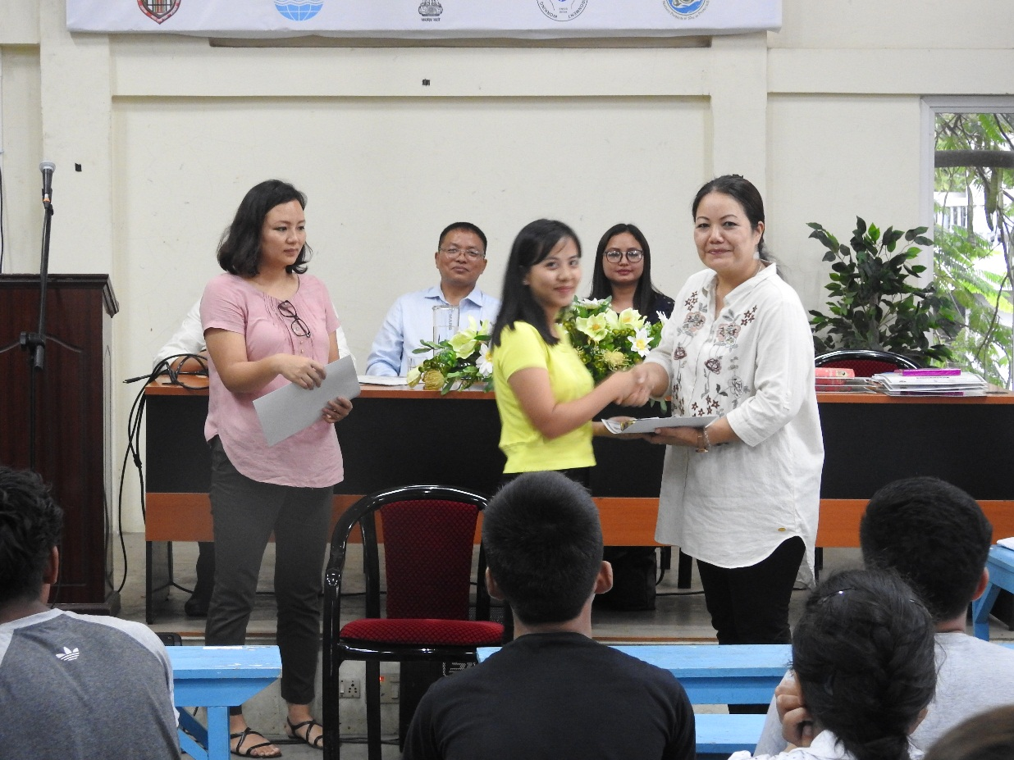
Pic 7: Prizes being given away

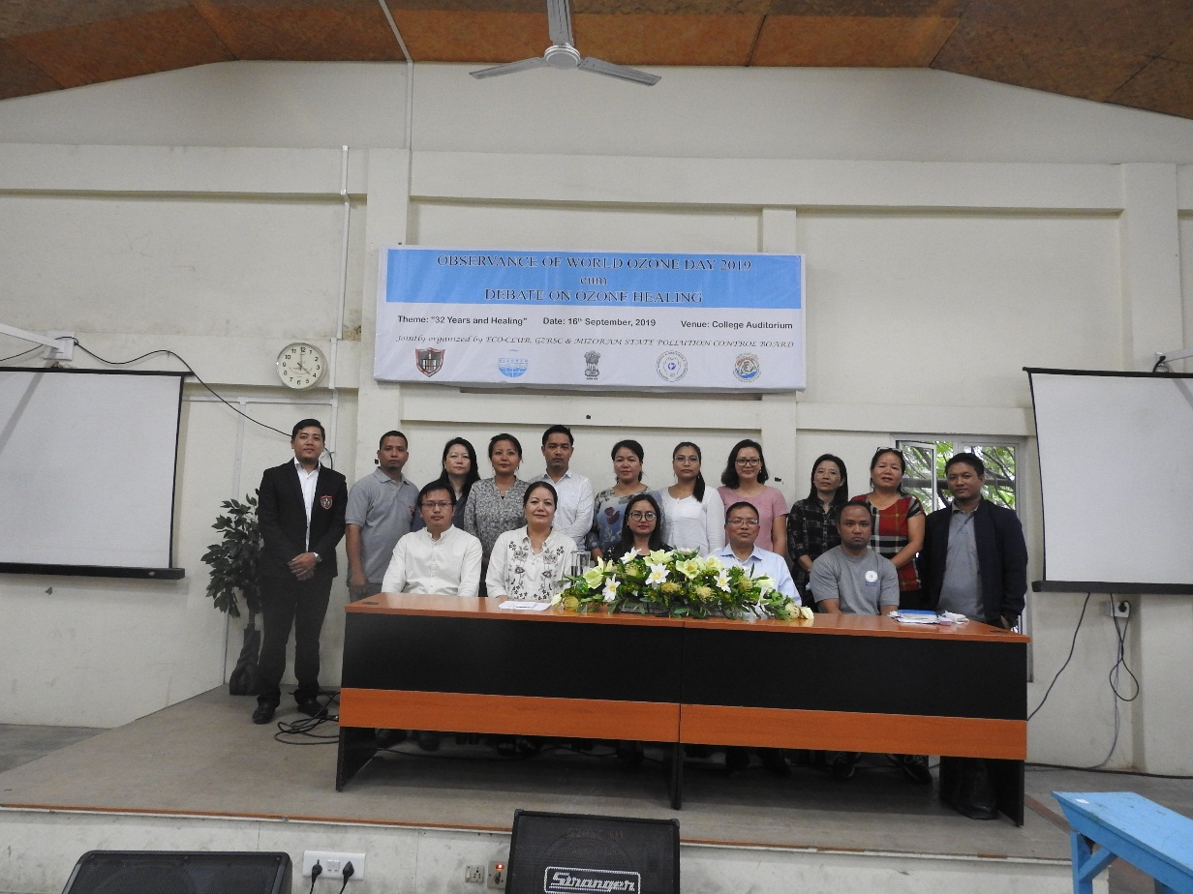
Pic 8: Eco-Club members, judges and Mizoram ENVIS Hub staffs
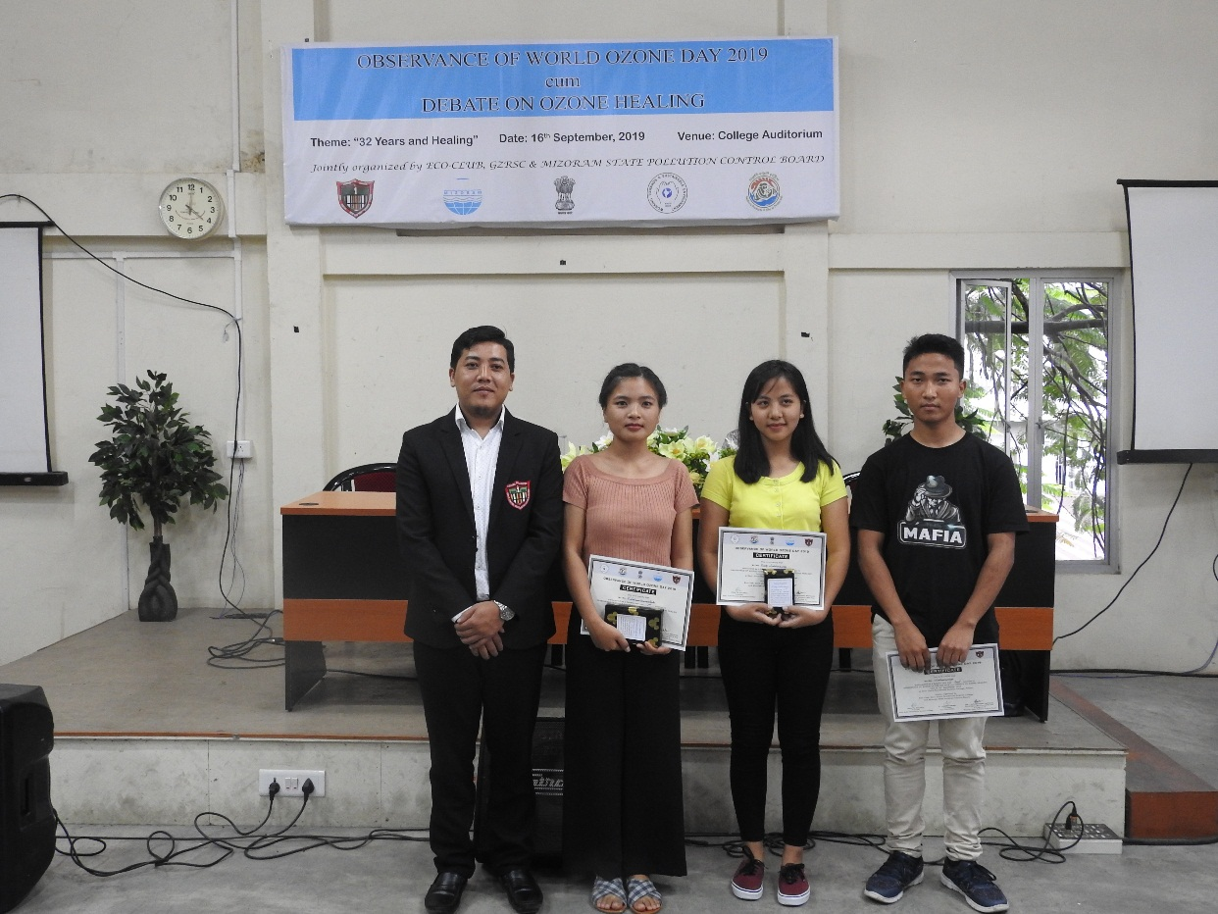
Pic 9: Dr C. Zoramthara with winners

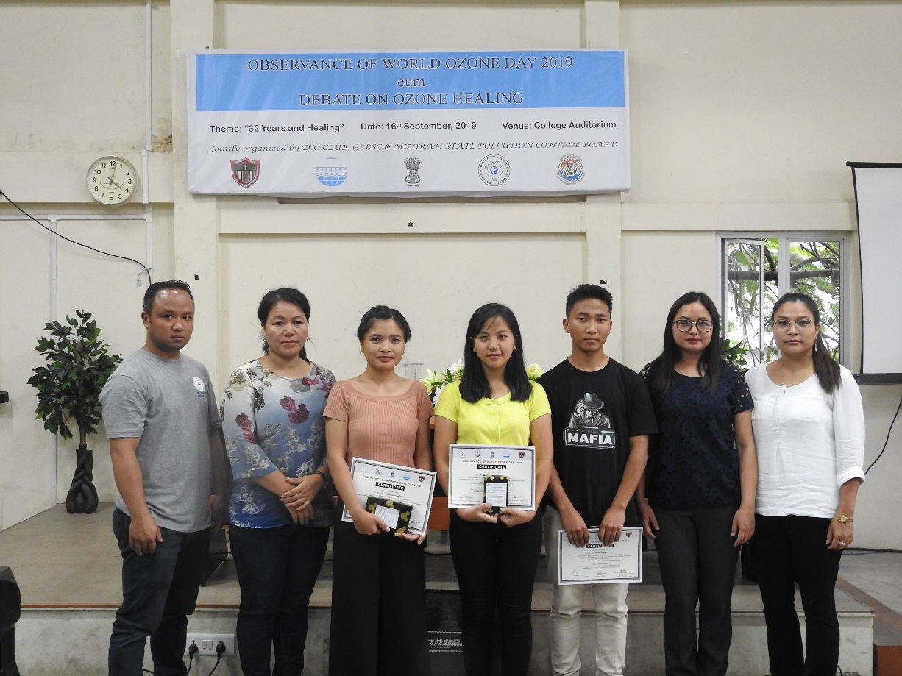
Pic 10: Mizoram ENVIS Hub staffs with winners

