GREEN MIZORAM PROGRAMME 2019

An environmental-related event “Green Mizoram Day” has been observed yearly by the Govt. of Mizoram since the year 1999 on 11th June. Since this date falls during vacation in college, Govt. Zirtiri Residential Science College observed the event on 26th July, 2019 by slightly changing the name to “Green Mizoram Programme”. The event was jointly organised by Eco-Club GZRSC and NSS GZRSC Unit.
The event was observed by planting trees in the new college campus at Durtlang Leitan. A total of 50 saplings including Khuangthli, Chawmzil, Pangkai, Herhse were planted with the aim of improving the environment especially of the new campus.
54 students altogether from Zoology (core) and Geology (core), and 8 teachers from Eco-Club and NSS participated in this event. A bus was hired for back and forth transportation of students and refreshment was served for all those who participated.

Report prepared by
C. Lalngaihawma
Secretary
Eco-Club GZRSC

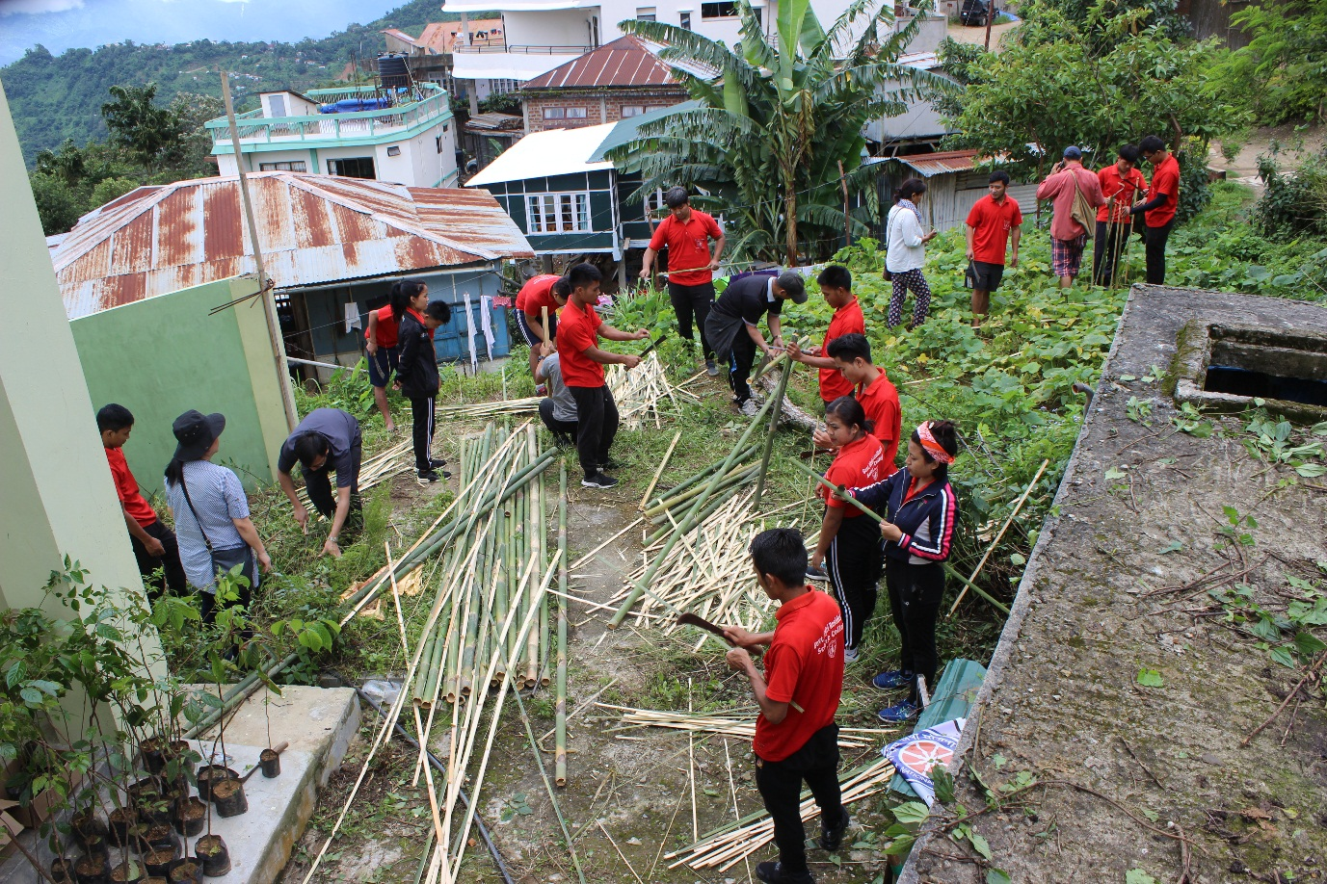
Pic 1

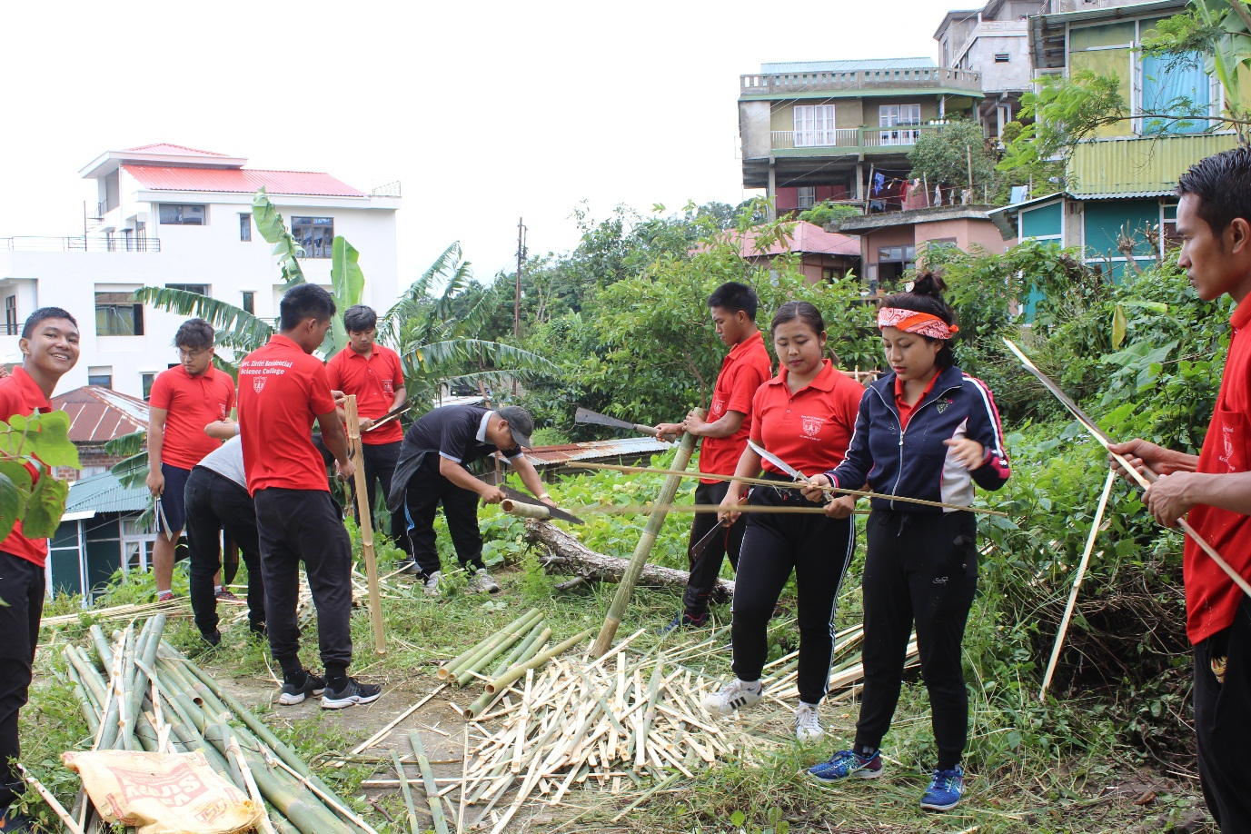
Pic 2

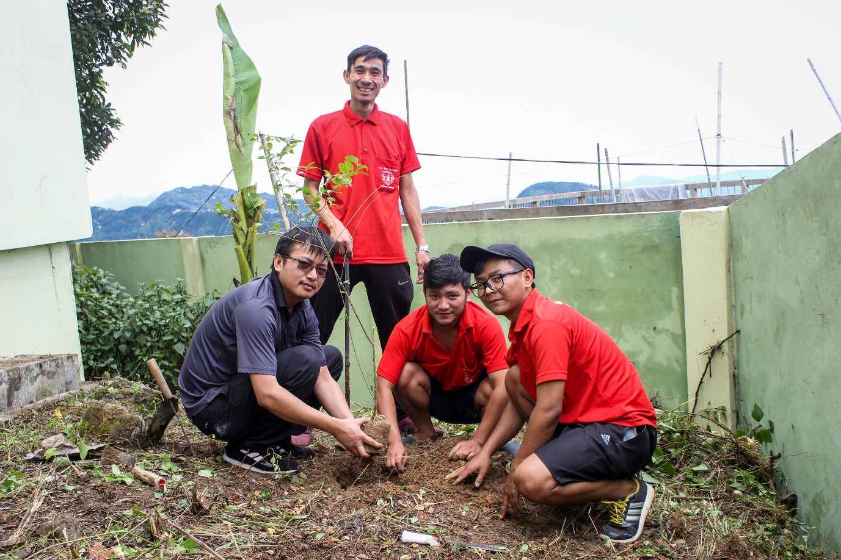
Pic 3

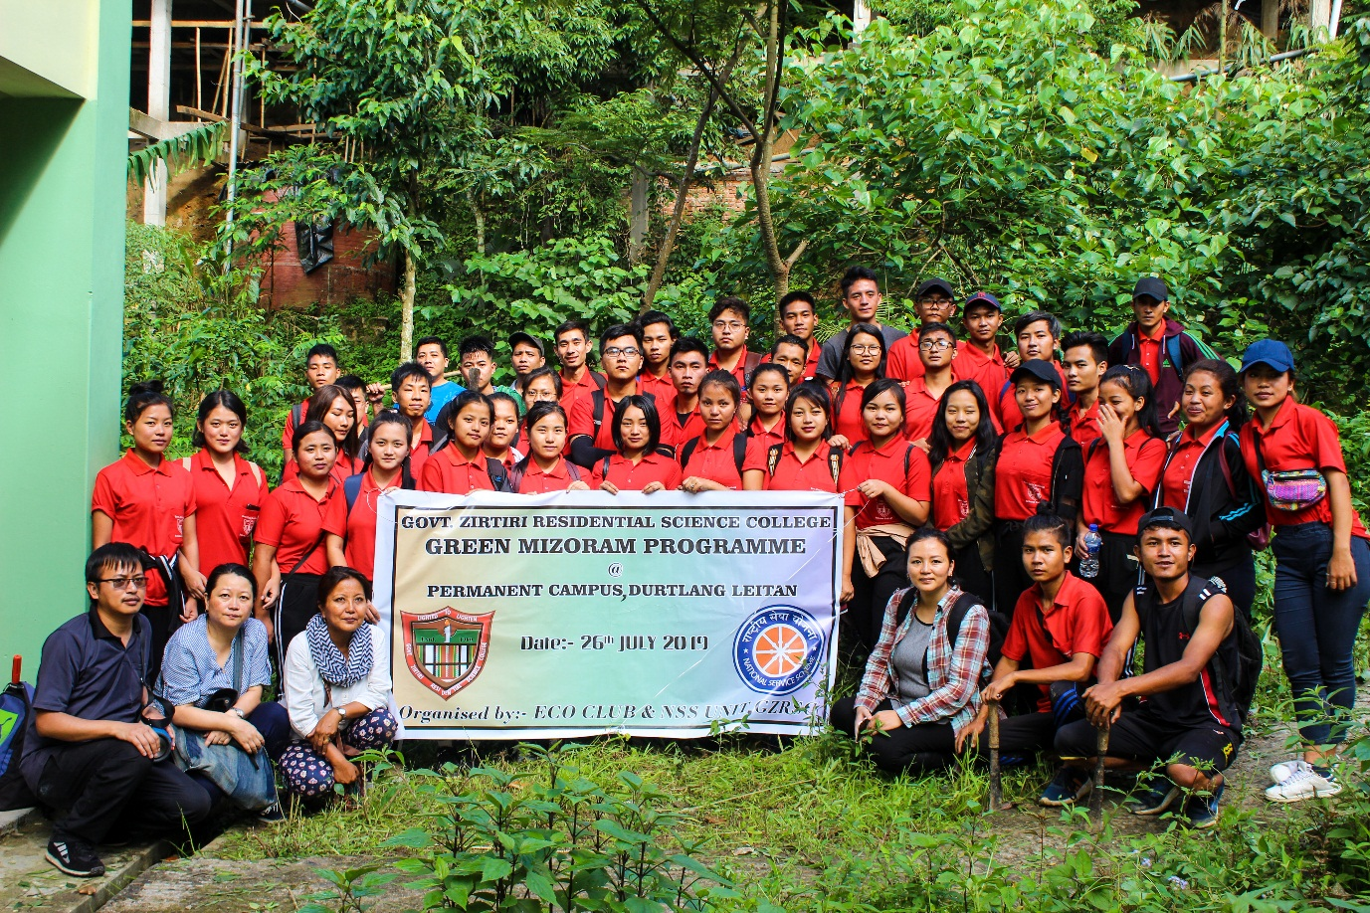
Pic 4

