Department of Home Science
Govt. Zirtiri Residential Science College
Aizawl, Mizoram.
Field Trip Report
Brief Report on Student Feld Trip i.e 5th Semester B.Sc (Home Science) held on 10th – 11th October 2019 at Silchar. We departed from Aizawl on the 10th of October 2019 at 5:00am and due to road block we were delayed at Sentlang, Mizoram for about 3 hours and reached our destination Silchar around 7:00 pm. On 11th October after breakfast along with the local tour guide we visited The North Western Cachar Tea Factory (Silcoorie tea) and Lalit Flour Mills. The students attend and observe informative lecturers regarding the techniques and different methods for processing at the factory. Photograph of different sites were also taken.
Total number of Students : 9
Teacher’s (Guide) : 5
Driver and Conductor : 2
Total Members : 16
Total Expenditure : 20000
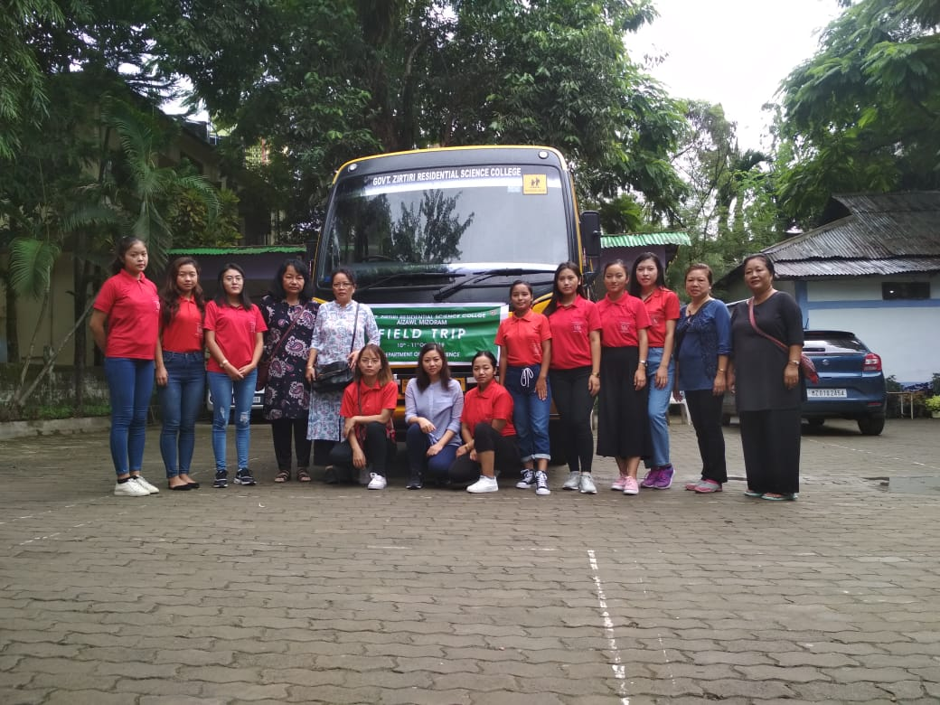

Place visited:
- 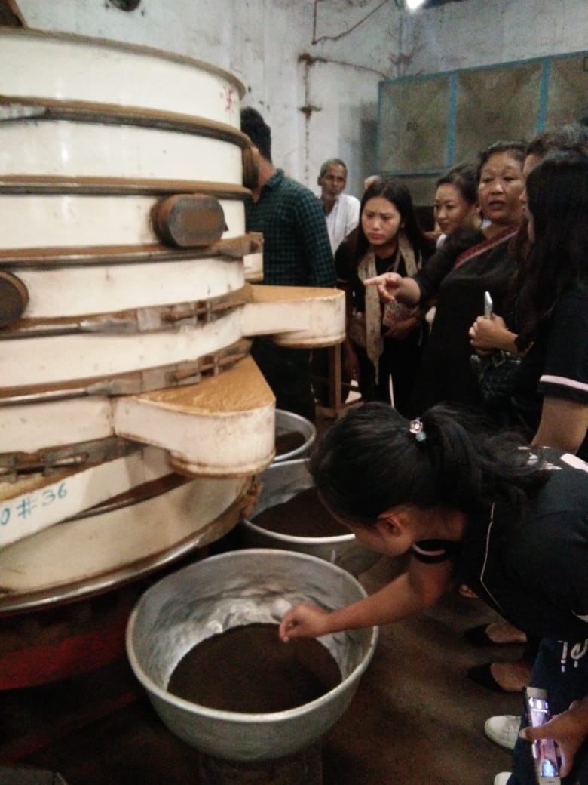The North Western Cachar Tea Factory ( SilcoorieTea): The factory was established in the year 1998 and they have around 600 workers, they export mainly in the Western part of India. They have different type of tea depending on the quality and they have their own tea plantation.
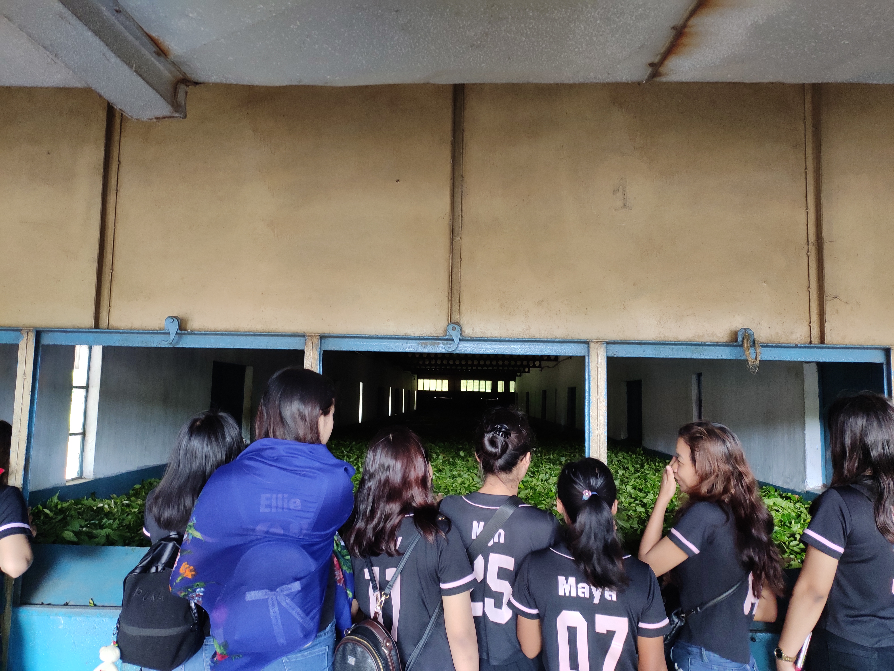

- Lalit Flour Mills: Located at Meher Pur , Silchar- 15, which is around 20 kms from the Central part of Slichar. They have well equipt mills and mostly they produce fine maida, suji, wheat bran and atta.
- 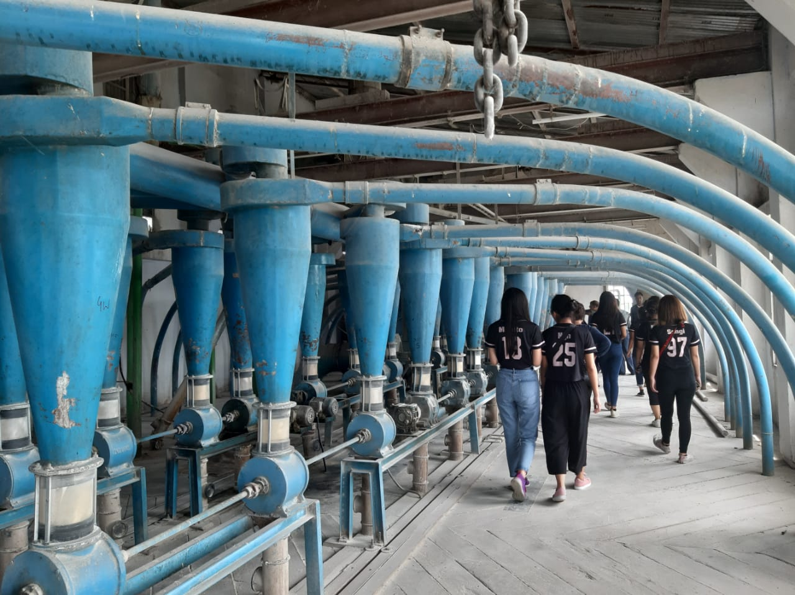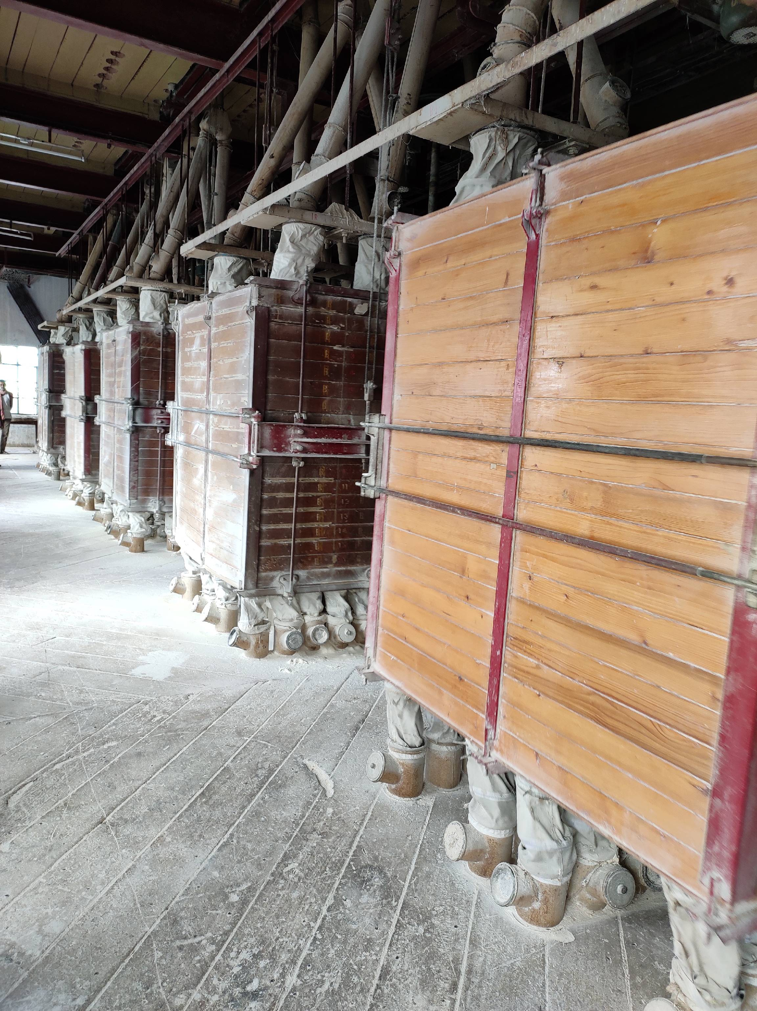The Lalit Flour Mills also owns cold storage facilities. The students were allowed to go inside the cold storage and were given information on how the cold storage works.

After the visit the owner gave us cold drinks and we were welcomed warmly. The students gained lot of information and experience .

